William Colon

3-1

Marketing With ePortfolios and Artifact Update

Using eportfolios and hosting on platforms such as Github offers several advantages in presenting skills and outcomes. They help you organize and update your projects with time stamps. This makes changes easier to pursue. The organization allows employers to easily navigate through various repositories to view changes. Additionally, eportfolios serves as an alternative to recovering lost work. This is extremely important in today's digital landscape. By integrating a curated selection of projects, writing samples, certifications, and testimonials, you can effectively demonstrate your expertise and unique value to potential employers or clients.

Moreover, setting the repository language on GitHub helps showcase proficiency in various programming languages, such as Python, Java, and C++. Multimedia elements like videos or presentations can enhance the interactivity of your ePortfolio, while SEO optimization can improve its online visibility, allowing you to reach a wider audience and establish a strong personal brand. Sharing your GitHub link during in-person interviews or virtual meetings provides a convenient way to present your work.

Eportfolios has many advantages, but also drawbacks. An important issue is the risk of supplying data from external sources, coupled with the lack of understanding of eportfolios in some employers. Without proper safety measures, files such as the project's main.cpp can be risked online. Luckily, GitHub offers security features to create written and secure projects with the option to place the repository in private settings. Despite these characteristics, many companies and employers may lack the knowledge to effectively use or understand when hiring new employees. Therefore, eportfolios can do quite a lot enhance self-promotion efforts, users must also be mindful of the challenges they may face in the process.

In my software design and engineering in C++, I have made significant progress in developing a robust application framework. While successfully implemented various features, I’m currently focusing on enhancing my skills in algorithms and data structures to optimize performance and efficiency. Additionally, I’m working on integrating database functionality to manage appointment data effectively, which will further streamline the application's operations and user experience. Continued efforts in these areas will strengthen my overall software development capabilities.

I've been trying to work with various databases, including MongoDB and SQL, but I've encountered several challenges that have hindered my progress. Currently, I'm focusing on using CSV files as a database solution, hoping it will simplify my data management and integration processes.

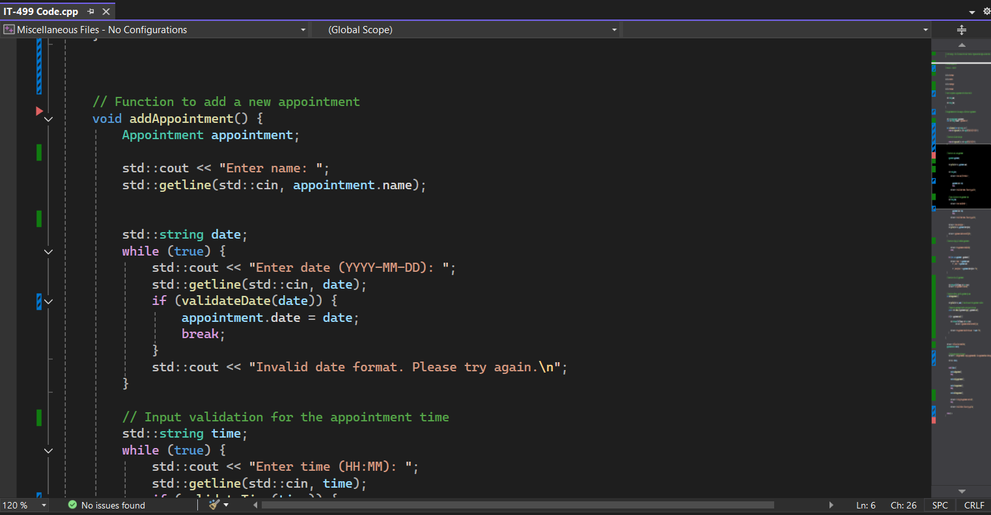

<https://github.com/williamcolon/CS-499/tree/82694ed5797d97f8391b03e7b3d34d11be553e9a/Appoitment>